**Stock Analysis with Screen Shots**

**2014**

In 2014 the best performing stock was Desktop Metal (DM), an American technology company that designs and markets 3D printing systems. Its stock price grew by 5581% over the year with a starting stock price of $0.69 and an ending stock price of $39.20. As of today, June 27, 2021, the stock is valued at $12.00.

The worst performing stock in 2014 was CBO which dropped by almost 96% over the course of the year. Its opening price was $23.40, and it ended the year at $1.00. There is limited information online today about CBO that I feel confident sharing as a part of my analysis.

The stock that had the most volume in 2014 was Bank of America (BAC) with a combined trading volume of 21,595,474,700 over the year. BAC is an American multinational investment bank and financial services holding company. BAC’s opening stock price was $15.57, and its ending stock price was $17.89, which was a total increase of 14.9% over 2014. Today it is valued at $41.62.

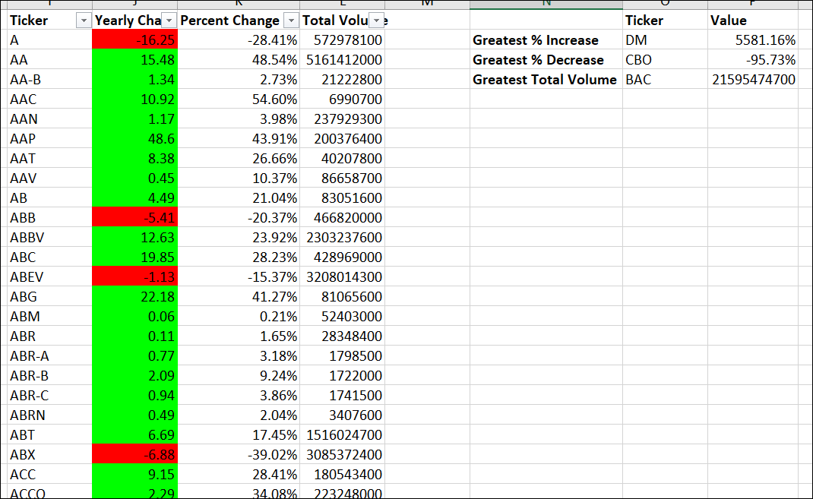

**2015**

In 2015 the best performing stock was ARMOUR Residential REIT, Inc. (ARR). ARMOUR Residential REIT operates as a real estate investment trust, which engages in the business of investing in fixed rate, hybrid adjustable rate and adjustable-rate residential mortgage-backed securities. Its stock price grew by 491% over the year, with a starting stock price of $3.68 and an ending stock price of $21.76. Today, June 27, 2021, the stock price is valued at $11.57.

The worst performing stock in 2015 was Kinder Morgan, Inc. (KMI.W). Kinder Morgan operates as a pipeline transportation and energy storage company. The company owns and operates pipelines that transport natural gas, gasoline, crude oil, carbon dioxide, and other products. Its stock price dropped by almost 99% over the course of 2015. Its opening price was $4.26, and it ended the year at $0.06. Today KMI is valued at $18.29.

Bank of America (BAC) was also the most highly traded stock of 2015 with 21,277,761,900 total transactions. BAC’s opening stock price was $17.89, and its ending stock price was $16.83, which was a total decrease of -1.05 % over the year.

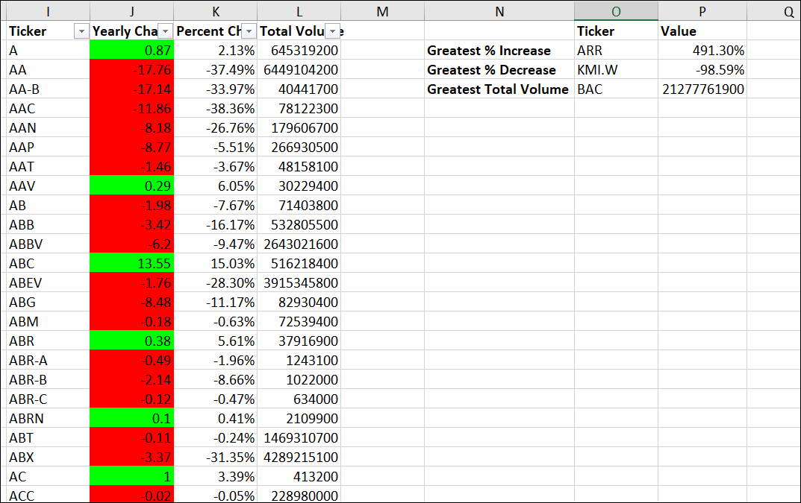

**2016**

In 2016 the best performing stock was StandRidge Energy (SD), a company engaged in hydrocarbon exploration in the United States. Its stock price grew by 11675% over the year, with a starting stock price of $0.02 and an ending stock price of $23.55. Today, June 27, 2021, the stock price is valued at $6.50.

The worst performing stock in 2016 was DYN.W. Its stock price dropped by almost 91% over the course of 2016. Its opening price was $0.47, and it ended the year at $0.04. There is limited information online today about DYN.W that I feel confident sharing as a part of my analysis.

Bank of America (BAC) was also the most highly traded stock of 2016 with 27,428,529,600 total transactions. BAC’s opening stock price was $16.83, and its ending stock price was $22.01, which was a total increase of -31.31 % in 2016. Over the 3-year time frame analyzed, BAC’s stock grew by 41%.

